**Drain the Mixed Gas Holder Common Knockout Pot**

|  |  |
| --- | --- |
| Objective | Drain condensed liquids (water, wax, oligomers and potentially dissolved gases such as TFE and HFP) from the MGH Common Knockout Pot.  During the 2018 TAR, the drain process was automated due to a PHA recommendation. |

|  |  |
| --- | --- |
| Initial Equipment Status | * MGH is online. * Knockout Pot is online. * No Autoclave is venting or preparing to vent. |

|  |  |
| --- | --- |
| Procedure Outline | 1. DCS draining process description 2. Drain Common Knockout Pot manually. |

|  |  |
| --- | --- |
| Safety Requirements | * Control access to the Common Knockout Pot * Maintain barricade around the Common Knockout Pot area to prevent personnel exposure. * Full Face Breathing air required within the Common Knockout Pot barricade area. * While manually draining the Common Knockout Pot, operator must actively monitor DCS during draining process. |

|  |  |
| --- | --- |
| Affected Process Variables to Monitor | * Common Knockout Pot Level Transmitter 990LT * Common Knockout Pot Pressure Transmitter 990PT |

|  |  |
| --- | --- |
| References | * W1772634 * SCOD FPA-HON-117 * COD P-1890 |

|  |  |
| --- | --- |
| Automated DCS Operation Basis | During TAR 2018, the Common Knockout Pot drain operation was automated. During normal operation, Operators will not need to stand at the drain and open the valve to de-inventory the pot during normal operation. The risk of exposure to toxic gases during the drain operation was unacceptable. |

Continued on next page

**Drain the Mixed Gas Holder Knockout Pot, Continued**

|  |  |
| --- | --- |
| Automated DCS Graphic | The updated Common Knockout Pot graphic is shown below. A key change is the selector for the 990HS drain valve mode:  **Operator**: In this mode the DRAIN_KO procedure is available for the operator to initiate on demand. A yellow pop up button labeled “Drain KO Pot” appears below the drop box. Selecting “Drain KO Pot” will run the DRAIN_KO operation.  **Automatic**: In this mode the DCS will run the DRAIN_KO operation every night at 02:00 AM.  **Off**: In this mode the operation of 990HS is disabled. The DRAIN_KO operation will not run. The valve can still be opened by the operator if 990HS faceplate is placed in operator. |

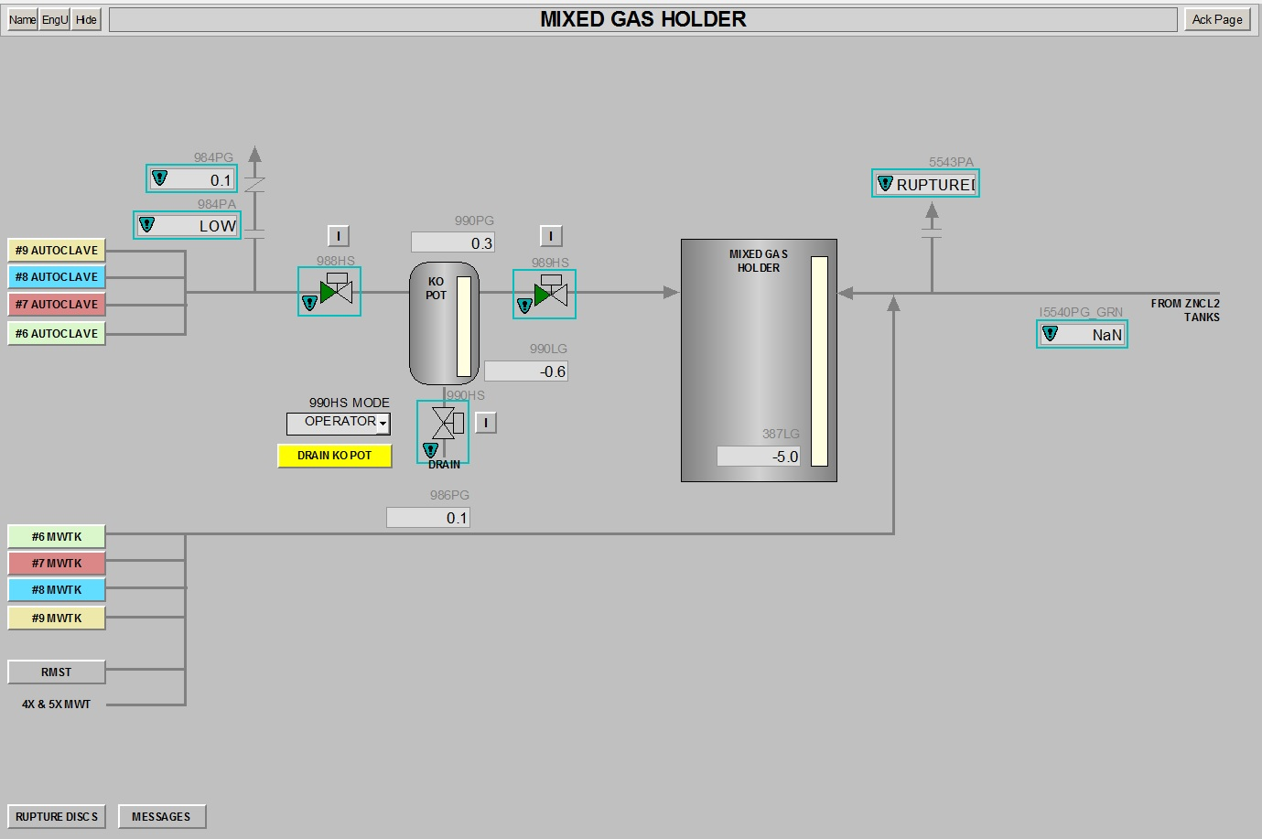

Continued on next page

**Drain the Mixed Gas Holder Knockout Pot, Continued**

|  |  |  |  |  |  |  |  |  |  |  |  |  |  |  |  |
| --- | --- | --- | --- | --- | --- | --- | --- | --- | --- | --- | --- | --- | --- | --- | --- |
| Key DCS Drain Requirements | These events interact with the sequence (these are not interlocks):   |  |  | | --- | --- | | **Event** | **Sequence Result** | | Any Autoclave in venting (progress flag) | Drain not allowed | | Any Autoclave vent valve open | Drain not allowed | | HFP vent valve open (1004HS) | Drain not allowed | | MGH line pressure > 15 psig | Drain not allowed | | Common KO Pot level <4% | Skips draining | | Drain takes long time (30-45 sec) | Drain stops | |

|  |  |
| --- | --- |
| Personnel Attendance During Drain | During Automatic or Operator draining of the Common KO Pot, operator attendance at the pot is not required. |

|  |  |
| --- | --- |
| Manual Procedure Steps | The Common MGH KO pot does not have a manual drain valve.   * These steps describe operating the automatic valves by placing them in manual. * The valves will continue to interlock. The DCS will take control based on interlock settings.  1. Isolate the Common Knockout Pot from the MGH by closing the exit automatic valve (989HS). 2. Close the inlet automatic valve (988HS) to isolate the Knockout Pot from the Autoclaves and HFP. 3. Open the drain valve (990HS) on the bottom of the KNOCKOUT POT and drain the pot until 10% level is attained. 4. Close the drain valve (990HS). 5. Open the exit valve (989HS) to the MGH to put in service. 6. Open the inlet valve (988HS) from the Autoclaves and HFP. 7. These valves must be in open or the Autoclave vent will wait and alarm. |

End of Topic

**Common Knockout Pot Interlocks**

**990HS (Common KO Pot Drain Valve) (These conditions close valve)**

|  |  |  |  |
| --- | --- | --- | --- |
| **Device** | **First Out** | **PV** | **Trip** |
| MGH KO POT LOW LOW LEVEL (990LG) | X | # | 1.50 |
| MGH KO POT HIGH PRESSURE (990PG) | X | # | 15.00 |
| MGH KO POT INLET VALVE OPEN (988HS) | X | N/A | Open |
| MGH KO POT VENT VALVE OPEN (989HS) | X | N/A | Open |

**988HS (Common KO Pot Inlet Valve) (These conditions close valve)**

|  |  |  |  |
| --- | --- | --- | --- |
| **Device** | **First Out** | **PV** | **Trip** |
| MGH KO POT DRAIN VALVE OPEN (990HS) | X | N/A | Open |

**989HS (Common KO Pot Outlet Valve) (These conditions close valve)**

|  |  |  |  |
| --- | --- | --- | --- |
| **Device** | **First Out** | **PV** | **Trip** |
| MGH DRY LINE HIGH PRESSURE (986PG) | X | # | 15.00 |
| MGH KO POT DRAIN VALVE OPEN (990HS) | X | N/A | Open |
| MGH HI LEVEL (387LG) | X | # | 80% |

End of Topic